Pro3

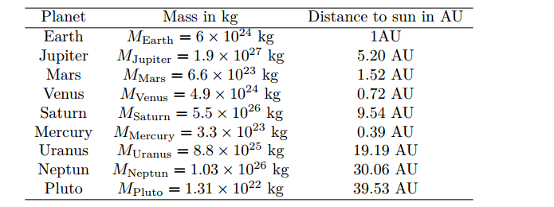

3 a)

1.Euler method (not good for precise

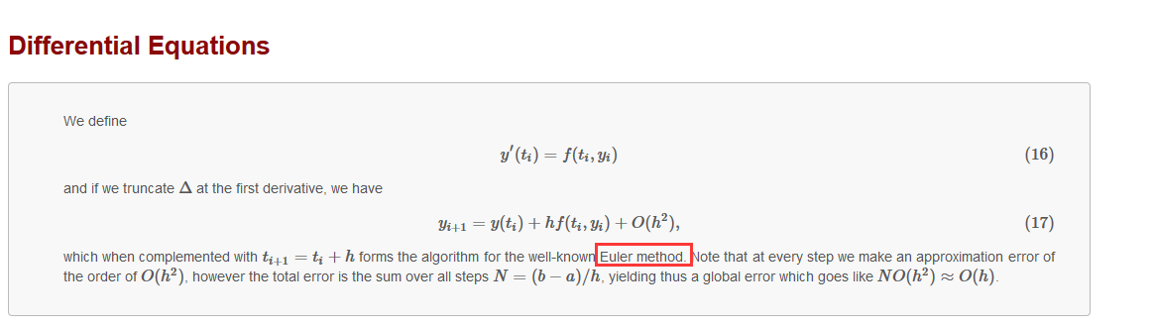

Get positon (x,y), ----v(x,y), a(x,y)

2. Velocity verlet algorithm (numerically stable)

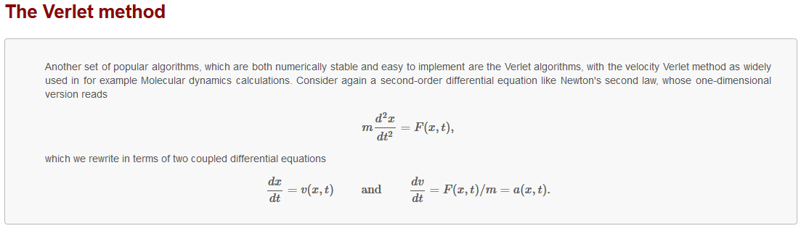

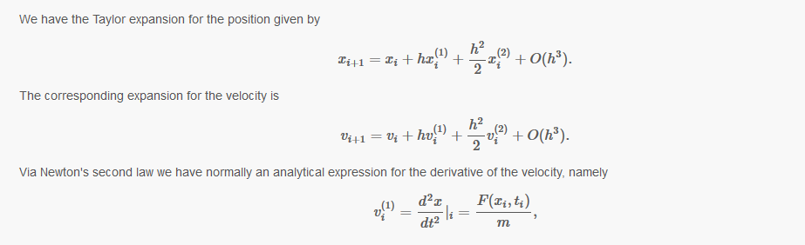

b) object : make class,

private:

public:

c)

1.to get a circular orbit – find a proper velocity value; change $∆t$, test stability( ); make plot for the position of Earth

2. check the kinetic , the potential energies , angular momentum conserved? Explain why?

3. Compare differences between the Verlet algorithm and the Euler algorithm. Consider also the number of FLOPs involved and perform a timing of the two algorithms for equal final times

d)

1. escape velocity( Can you find an exact answer); compare with numerical results

2. change the gravitional force, $βϵ\left[2,3\right]$, when β creeps towards 3,What happens to the earth-sun system ( compare *V*escape) ? Comment your results.

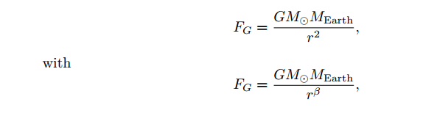

e)

find out how much Jupiter alters the Earth’s motion.